Evaluating a Local Church According to the Healthy Church Model

The Healthy Church Model gives us a clear definition of what constitutes a healthy church.
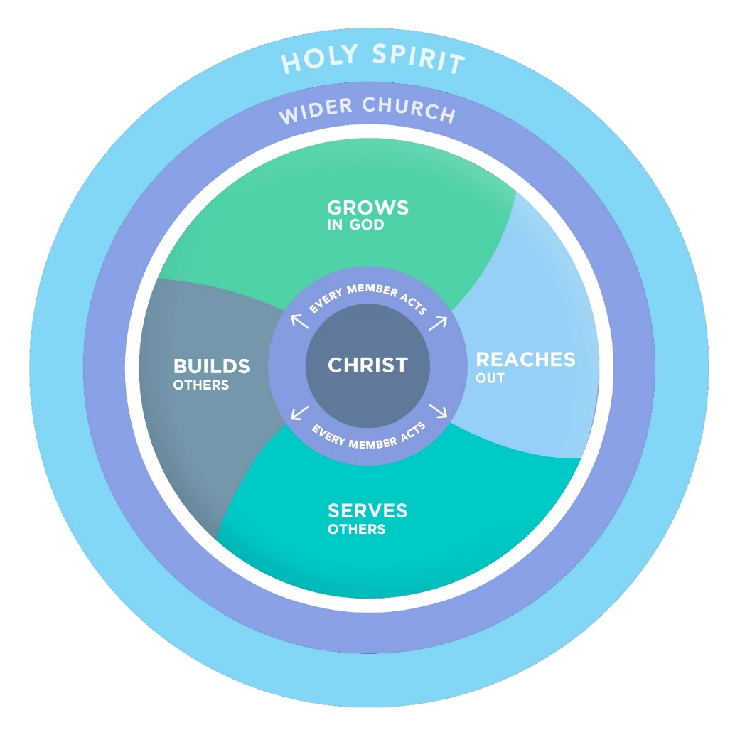

This model shows us the seven areas in which we need to be healthy:

- Union with Christ
- Everyone functioning
- Grows in God
- Serves others
- Builds others
- Reaches out
- Relationships with the wider church, in the fellowship of the Holy Spirit

In your team, please consider your own churches and evaluate their health by answering the following questions in these seven areas:

- Union with Christ
  - What is the quality of the spiritual life in your church?
  - How many people, individually, know God?
  - What is the spiritual quality of your corporate meetings?
  - When you need to determine future direction, do you only brainstorm and strategize or do you pray and seek God?
- Everyone functioning
  - Who is functioning in your church? Everyone or just a few?
  - Is everyone active or are people mainly passive? Are the people participants in the life of the church or spectators?
  - How are they functioning? What are they doing?
  - What percentage of the ministry work is done by professional paid staff and how much by unpaid people in the church?
- Grows in God
  - Realistically, how many people are growing in God?
  - In what specific ways are they growing?
- Serves others
  - Realistically, how many people are serving others?
  - In what specific ways are they serving?
- Builds others
  - Are the parents building the children?
  - Are the older women building the younger women?
  - Are the older men building the younger men?
  - Are people making new disciples?
  - Are leaders building leaders?
- Reaches out
  - Realistically, how many people reach out to the lost around them?
  - In what specific ways is your church involved in cross-cultural missions work?
- Relationships with the wider church, in the fellowship of the Holy Spirit
  - In what specific practical ways are you connected with other churches?

Of course, no church is perfect! Every church on the earth – and indeed in the book of Acts – needs to grow in all these areas.

